AI Migration Intelligence System (AMIS)
Auto discover source system, historical mapping, specific hidden business rules and reduce 80% of cross department communication cost. It also provide a lower comprehensive operation cost compared with traditional consultation company (EY, Deloitte) and more compliance enterprise data migration solution.

Paint point vs AI Solution
Pain Point
- Knowledge Silos: Key rules or data mapping distributed across different department subject matter experts (SME) or old program code and PDF file.
- Continuous cross department communication and probability missed key information
- High risk and cost: Rely on outside consultant company, missed hidden rules during the migration process

AI Solution
- Autonomous rule discovery: Combination of static code analysis and data profiling, auto dilute the hidden business operation logic.
- Unified knowledge graph: Define the data dictionary, historical mapping and cross department documentation as a atlas, generate a comprehensive metadata repository
- Auto-generated recon scripts: Auto generate validation strategy and validation scripts, automation reconciliation

Tech Stack & Tooling
LLM & Agent Engine | OpenAI API | - Knowledge Extraction  - Static Analysis  - Recon Script generation
Graph Database | Neo4j / NetworkX | - Built up knowledge graph  - Showcase correlation between data field and business logic
Vector DB | Qdrant / Pinecone / ChromaDB | - Store data dictionary  - PDF  - Conversation email  - Act as the RAG agent
Static Code Analysis | Tree-sitter / Custom Parser | - Understand old system  - hardcoded logic  - conditional rules
Data Mining | Python (MLxtend / scikit-learn) | - Execution association rule mining  - Apriori  - FP-Growth  - Analysis historical data mapping  - Discover hidden relationship (comparison)
Frontend & Demo0 | Streamlit / React + Tailwind CSS | Hackathon fast develop interaction UI

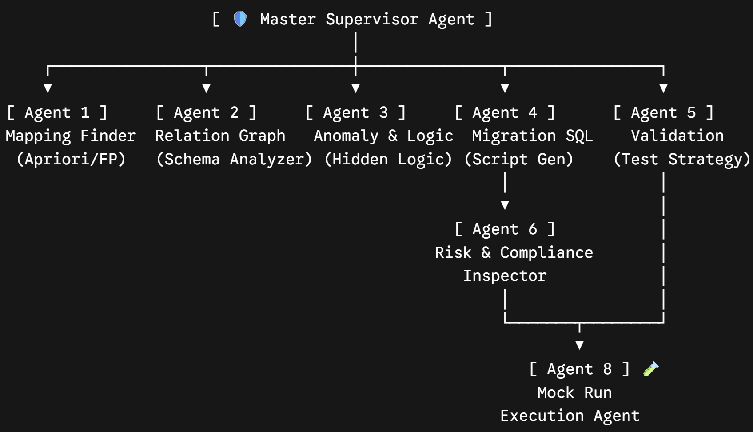
Historical Mapping Agent 1 | - Association Rule Mining (Apriori / FP=Growth)  - Embedding Model
Relationship Graph Agent 2 | - Discover source and target system metadata & comparison logic  - Technique: Neo4j / Knowledge Graph
Hidden Logic & Anomaly Agent 3 | - Handle the mis-match / conflict point between Agent 1 & 2, edge cases and comparison logic that come out from cross department documentation  - Technique: Static Code Analysis, Data Profiling
SQL Script Generator Agent 4 | - According to Agent 1, 2, 3 outputted mapping rules and knowledge graph, auto generate production level data migration SQL  - Technique Migration Pattern Library from OpenAI Codex
Validation Strategy Agent 5 | - Automate generate comprehensive data reconciliation strategy (data scenario) & verification script (sql script)  - Technique: Sampling test, record count verification, sum check, unmatched recon script
Risk & Compliance Inspector Agent 6 | - Double check Agent 4 generated migration SQL and Agent 5 validation strategy, ensure suite with business logic, fulfilled compliance.  - Technique: Rule Engine / LLM Judge -> Show migration risk score + recommendation
Mock Run Execution Agent 8 | - Execute A4 generate data migration SQL, Auto monitor performance, execution log, and catch execution error (runtime error, data truncation, constraint violations)  - Technique: Dockerized sandbox, temporary database, SQL Parser, Rollback & Dry-run mechanism
Master Supervisor Agent 7 | - Full range work orchestration, task delegation, monitor all agent execution status  - Technique: LangGraph, AutoGen Framework

P1 - Discovery | P2 - Review & Synthesis | P3 – Generation Phase | P4 – Inspection & reporting Phase
A1: Abstract historical mapping  A2: Build up Neo4j relationship diagram  A3: Understand program and anomaly information + Figure hidden business rules | Combination of A1, A2, A3  Output: Comprehensive Business Rule Matrix | A4: Generate migration SQL rules  A5: Parallel generate validation strategy (Recon Scripts) | A6 validate SQL & validation strategy risk and compliance  A7: Generate final report, if still unsolved issue, raise help from SME for manual verification

Presentation
- Role-Based Specialization
- Deterministic & Agentic Hybrid
- Human-in-the-Loop & Alerting System

ARCHIVE

AI Migration Intelligence System
AI will help the company to discover out the hidden rule during the data migration

Current Issue:
- Need whole team to discover out the hidden rule behind the system 1b1 by having lot of conversation between each department, its time consuming and may having misunderstanding / missed some information.
- The data migration team have no comprehensive system knowledge, each of the knowledge only stored inside each department specific people only

Selling Point:
- Help company discover out the hidden rule during the data migration
- Provide less price and time with equal risk and compliance if compared with EY
- Auto analysis source system, data dictionary, historical mapping
- Auto discover business rules
- Auto develop script (validation strategy) based on multiple data scenario

Input:
- Oracle Table
- SQL Server Table
- Excel mapping
- Migration Specification
- Data Dictionary
- PDF, Conversation Email, COBOL Program

Output:
- Migration Risk Score
- Discovered Business Rule
- Generated Migration Plan
- Tech Recon Package (source\target count, unmatch\match record, recon report)

AI Workflow:
- Upload enterprise knowledge
- Discover hidden business rule
- Detect missing data mapping
- Generate validation strategy

AI Layer:
- Knowledge Extraction ( JSON: { “field”:”ACCT_STATUS”, ….. } )
- Knowledge Graph (Account status -> Dormat -> Card Block -> Online Banking Disabled) ( The relationship map between each data mapping)
- Rule Discovery

How to verify the code is correct?
- SME validation
- Historical data validation
- Sampling test
- Recon validation

How I can make the AI can auto
- Analysis source system
  - Built up metadata repository
  - Get the data field name
  - Build up relationship diagram (Neo4j
- Analysis data dictionary
  - Convert to JSON file
  - Save into RAG
  - When another AI Agent request the info, can straight get it and present to
- Analysis historical mapping
  - Collect certain amount of historical mapping, train the embedding
    - Association Rule Mining: Apriori / FP-Growth
- How to auto discover business rules
  - Static Code Analysis
- How to generate validation strategy
  - Generate recon script
    - Using Migration Pattern Library
      - Rule Classifier

- How to discover hidden rules during data migration
  - Association Rule Mining



